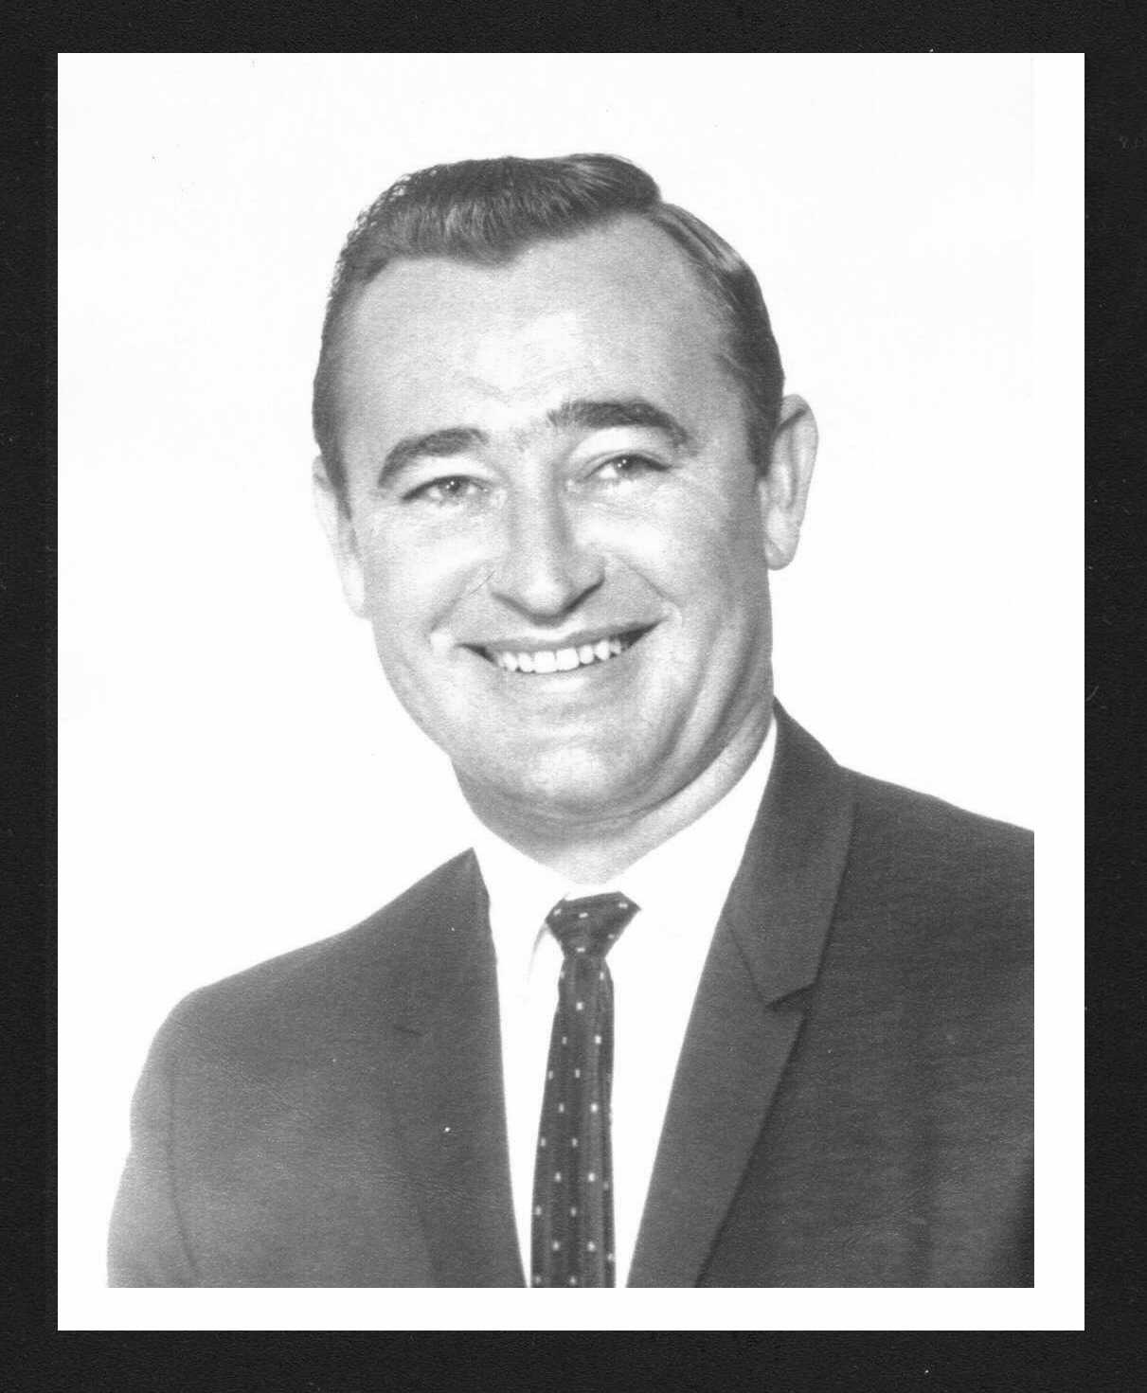

In Loving Memories
James Lee Craig
1933-2000

Page 12

The Craig Family would greatly appreciate contributions to:
Dr. Burzynski’s Cancer Coalition Fund for Children
In Memory of James Lee Craig
9432 Old Katy Road, Suite 200
Houston, Texas 77055

Proceeds will go to provide treatment for little kids whose families have simply run out of money to continue waging the costly fight against cancer when conventional methods have failed.
(Jim would have loved that.)

Page 1

“All I Have Needed Thy Hand Hath Provided.
‘Great Is Thy Faithfulness,’ Lord Unto Me.”
Lamentations 3:22-23, Lyrics and Music by Chisholm & Runyon
(Jim Craig’s favorite hymn...the one he sang in the shower)

Page 2

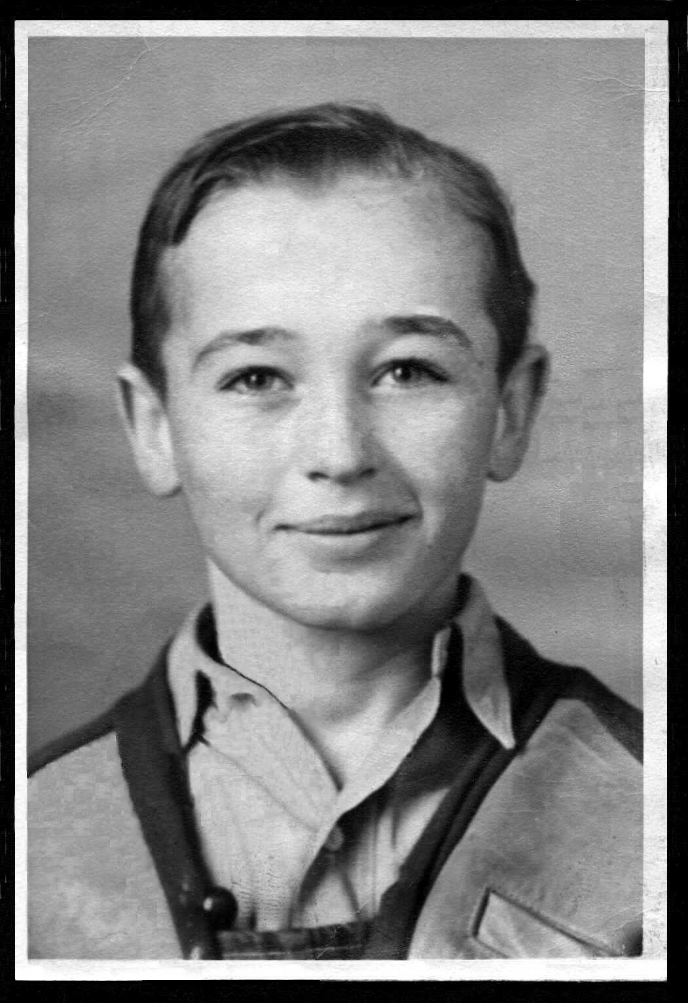
On November 30, 1933, “Jimmey Lee” Craig was born into the harsh life of a poor, country family hit hard by the Depression. His father was a mason and blacksmith, hammering out only a barely subsistence living to support two sons and their mother. And she was terribly ill during most of Jimmey Lee’s childhood.
Such circumstances compelled Jimmey, from a very young age, to take up his father’s rifle, learn to shoot and hunt small game that his family might have meat on their table.

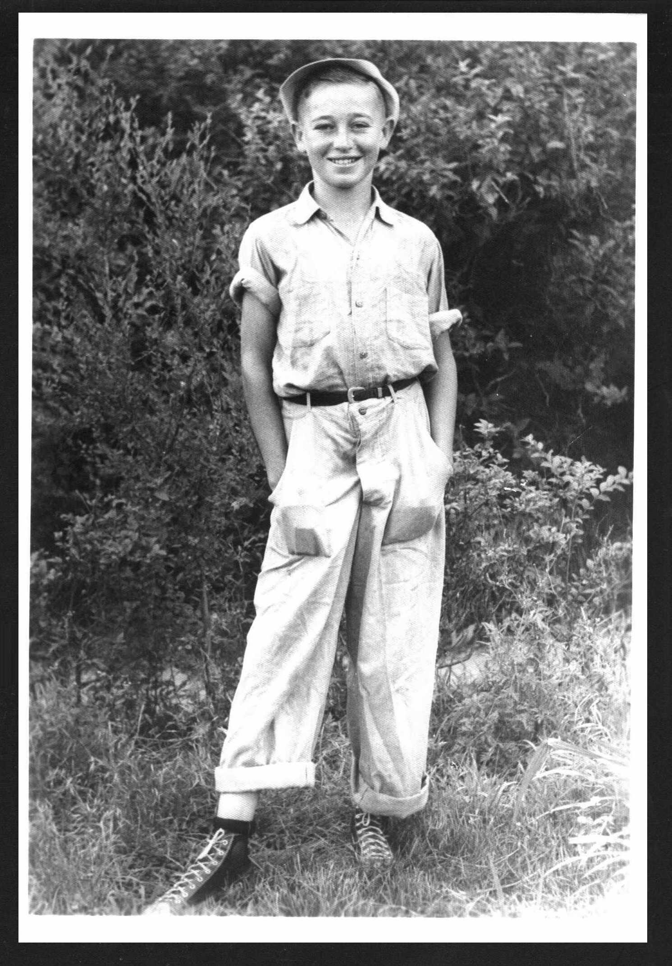
This is a true story. Though Jimmey, an intensely private person, seldom spoke of his past, especially any pitiable hardships. More often, he’d tell the tale of having had to walk six miles to school, barefoot in a blizzard, “uphill both ways!” Then he’d chuckle to himself.
Jimmey did, in truth, hitch-hike at the age of 13 from Yellville, Arkansas to Branson, Missouri, seeking better schooling. The School of the Ozarks (now College of the Ozarks) was a small, vocational High School that sought to instill upstanding Christian character, strong work ethics and real-life job skills in addition to academics.

Page 11
Through it all, Marybeth was, as always, uniquely Marybeth. Strong of spirit, calm in a crisis, a comforting mother to her grieving children and, above all, loving wife of the man she could only watch sleep as he slipped away from her. He was her very best friend in the world, as she was his. To the very end, Jim held fast to that small, brown teddy bear; the one she brought to the hospital for him, the one he bought at that hospital for her, his beloved Marybeth.
James Lee Craig passed away in the early morning hours of January 26, 2000. Peacefully. Mercifully. And greatly loved. Most assuredly, he was embraced in heaven by his Lord and Savior who said, “Well done, my good and faithful servant.”

Page 10
Chuck Slay, Jim’s son-in-law, became indispensably dispatchable; making calls, running errands, racing at any open hour to a pharmacy for medicines and supplies. One night, he and Amy rushed to help Marybeth hoist her semiconscious, deeply drugged husband from car to house after a trip to the Emergency Room.
As for Marybeth, she rarely left Jim’s side. And she never, for even a minute, left him home alone.
The Craig family held on to hope and, to this day, believe that Burzynski’s cancer treatment might well have worked, if only given enough time. But the cancer had already spread too far, too fast while earlier chemotherapy had poisoned his whole body.
On Sunday, January 23rd, paramedics were called to the Craig home and Jim was taken to Desert Hospital. His caregivers, Marybeth, Kevin, Amy and Chuck, had exhausted all humanly possible care. They followed the ambulance, with Marybeth bringing along a small, brown teddy bear. It had been her husband’s gift to her only months before while she was in the same hospital for back surgery.
Doctors left no doubt, leaving less hope, telling Jim’s loved ones, “He’s dying, you know.” By then, cancer had a strangulation grip on one lung, collapsing it. He was given only three days to live.
For the next 72 hours in Hospice, Jim only occasionally opened his eyes, recognized a face, mustered a smile, held out a hand to hold. Kevin selected CD’s of his Dad’s favorite music to play for him and he read passages from Scripture. Amy spent an afternoon soothing her fitfully restless father with lotion massaged on his feet while speaking softly of her love for her Daddy.
Chuck took the early morning shift, toting a newspaper to read aloud and to simply talk to Jim about every important or mundane thing, from his very fine children to presidential politics and the weather.

Page 3
All S of O students were required to hold campus jobs to earn their room and board. Jimmey Lee arrived, eager to study and work, possessing little more than the clothes on his back and an old guitar. (That same guitar had traveled with him at age 12 to sing and play before an audience of 5,000 a the St. Louis Folk Festival.)
One of the many jobs assigned to Jimmey was working in the school’s cold storage locker where he processed the butchered meat that would provide meals for his fellow students. This included the task of hand-feeding meat into a power grinder. That job cost him the loss of two fingers—and his ability to play guitar.
It did not cost him his sense of humor, however. He genuinely laughed at the endless jokes in the dining hall when friends would poke forks at mystery meat in search of fingernails, and at their feigned choking gasps exclaiming, “I think I just got a bite of Jimmey Lee!” Years later, during the 60’s and 70’s, Jimmey made even more of what he’d lost and had the last laugh to boot. When flashing a two-fingered “Peace Sign” was the fashion, he’d flash back his stubbed fingered “Half Peace” in reply. He’d laugh and, long after, laugh again remembering the Peacenik’s dropped jaws and flabbergasted faces.
Being “handicapped,” as he, himself, would intentionally pun, Jimmey switched from fingering a guitar to blowing a horn. He became the School of the Ozarks’ star trumpet player. Also, he sang baritone in the Boys Quartet.
In his senior year, S of O hired a new music instructor to direct Chorus and Band. Fresh out of college, it was her first year of teaching. She was young, talented, smart, funny, very pretty...and single, too. But, alas—and this seriously dedicated teacher made sure all the boys knew this—she was also engaged to be married.
Her name was Miss Marybeth Rea.

Page 4
For as long as Miss Rea directed and Jimmey trumpeted, The Band Played On; but that was only to last three short months.
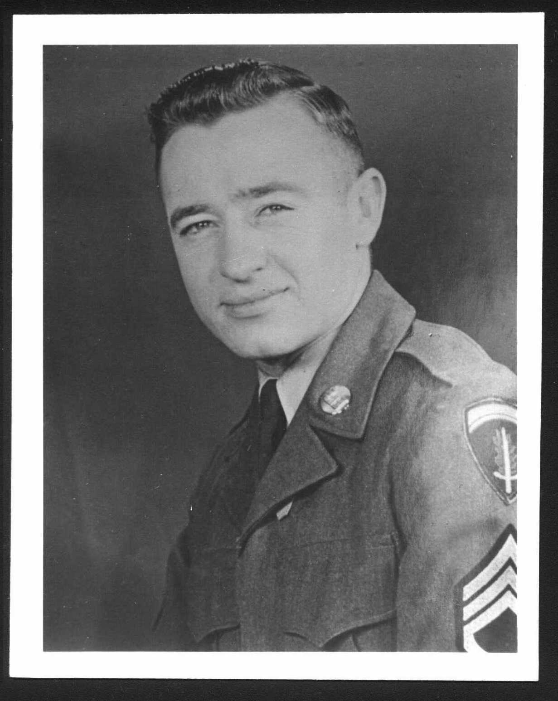
Jimmey left S of O to join the Army before the end of that senior year. By age 18, he’d been promoted to the rank of Sergeant in the Seventh Army’s Corp of Engineers; the 687th Water Supply Company. He was stationed in France.
During those four years, he kept a correspondence by mail with his former Music Teacher. Often, Jimmey’s letters teased Marybeth about her engagement and pending nuptials. He swore to her that he’d never fall into “the marriage trap” and insisted he’d remain a lifelong bachelor. Shakespeare would surely say, “Thou dost protest too much, me thinks,” but Marybeth believed Jimmey. He never gave her reason to suspect that his intentions were anything other than friendship.
But then, in one of Marybeth’s letters, Jimmey learned that she’d broken off her engagement. (This due to irreconcilable differences with her fiancé’s Roman Catholic faith.)
Given that news as well as an Honorary Discharge in hand—and, apparently with no further thought to confirmed bachelorhood in mind—Jimmey hightailed it back from France and quickly to Marybeth’s front porch. Only, from then on, he had every intention of courting, wooing and winning his Miss Rea. It only took him five years.
James Lee Craig and Marybeth Rea were married in her hometown of Branson, Missouri on December 26, 1955.
They honeymooned in...well...the next five decades.

Page 9
The next few rounds of chemo seemed to stall. No change. Still, Jim maintained his hope and his golf game, as if he hadn’t a care in this world—except to remember the need to wear a golf cap to keep the desert sun off his hairless head.
The last chemo infusions had the worst possible effect. No longer acting as a cancer-killing agent but, more like fertilizer instead. An explosion of cancer growth had metastasized to the lung.
Jim’s family rallied. Daughter Amy and her husband Chuck, poured over medical records, fed dozens of pages into a fax machine and obtained urgent admission for treatment at the Burzynski Institute then, made hasty travel arrangements. Marybeth and Kevin packed bags and boarded a plane with Jim and rushed him to Houston on December 21st. Upon arrival, wife and son were stricken by the flu. With the sick nursing the sickest, they spent three weeks, every single day including Christmas and the much touted Millennium New Year’s Eve, in a Cancer Clinic and a hotel suite.
Jim received the best imaginable care from Dr. Burzynski’s Institute. In this age of HMO “mill” medicine, the caring, compassionate, knowledgeable and professional treatment rendered to Jim was worthy of higher praise than can be written here. The doctor and his staff will have his family’s gratitude and support for many years to come.
Once home again, Jim’s family became his on-call and full-time, round-the-clock caregivers. Having quickly learned by Burzynski’s instruction, Kevin administered the complicated regimen of twice daily intravenous infusions plus scheduled dosings of over 70 pills. He proved to be a gifted caregiver to his Dad, ever vigilant and always patient even on the most difficult days and sleepless nights. Kevin was truly inspiring just to watch in his tender ministrations.
Amy took over management of the family’s various financial affairs—a torch that Jim had passed to his daughter months earlier in preparation for a possible worst case scenario. This Jim did with thoughts of Marybeth and wishing to spare her such a burden. Amy also provided homecooked ‘Meals-On-Wheels’ catering, helping feed mother and brother and hoping to fatten her wasting father.

Page 8
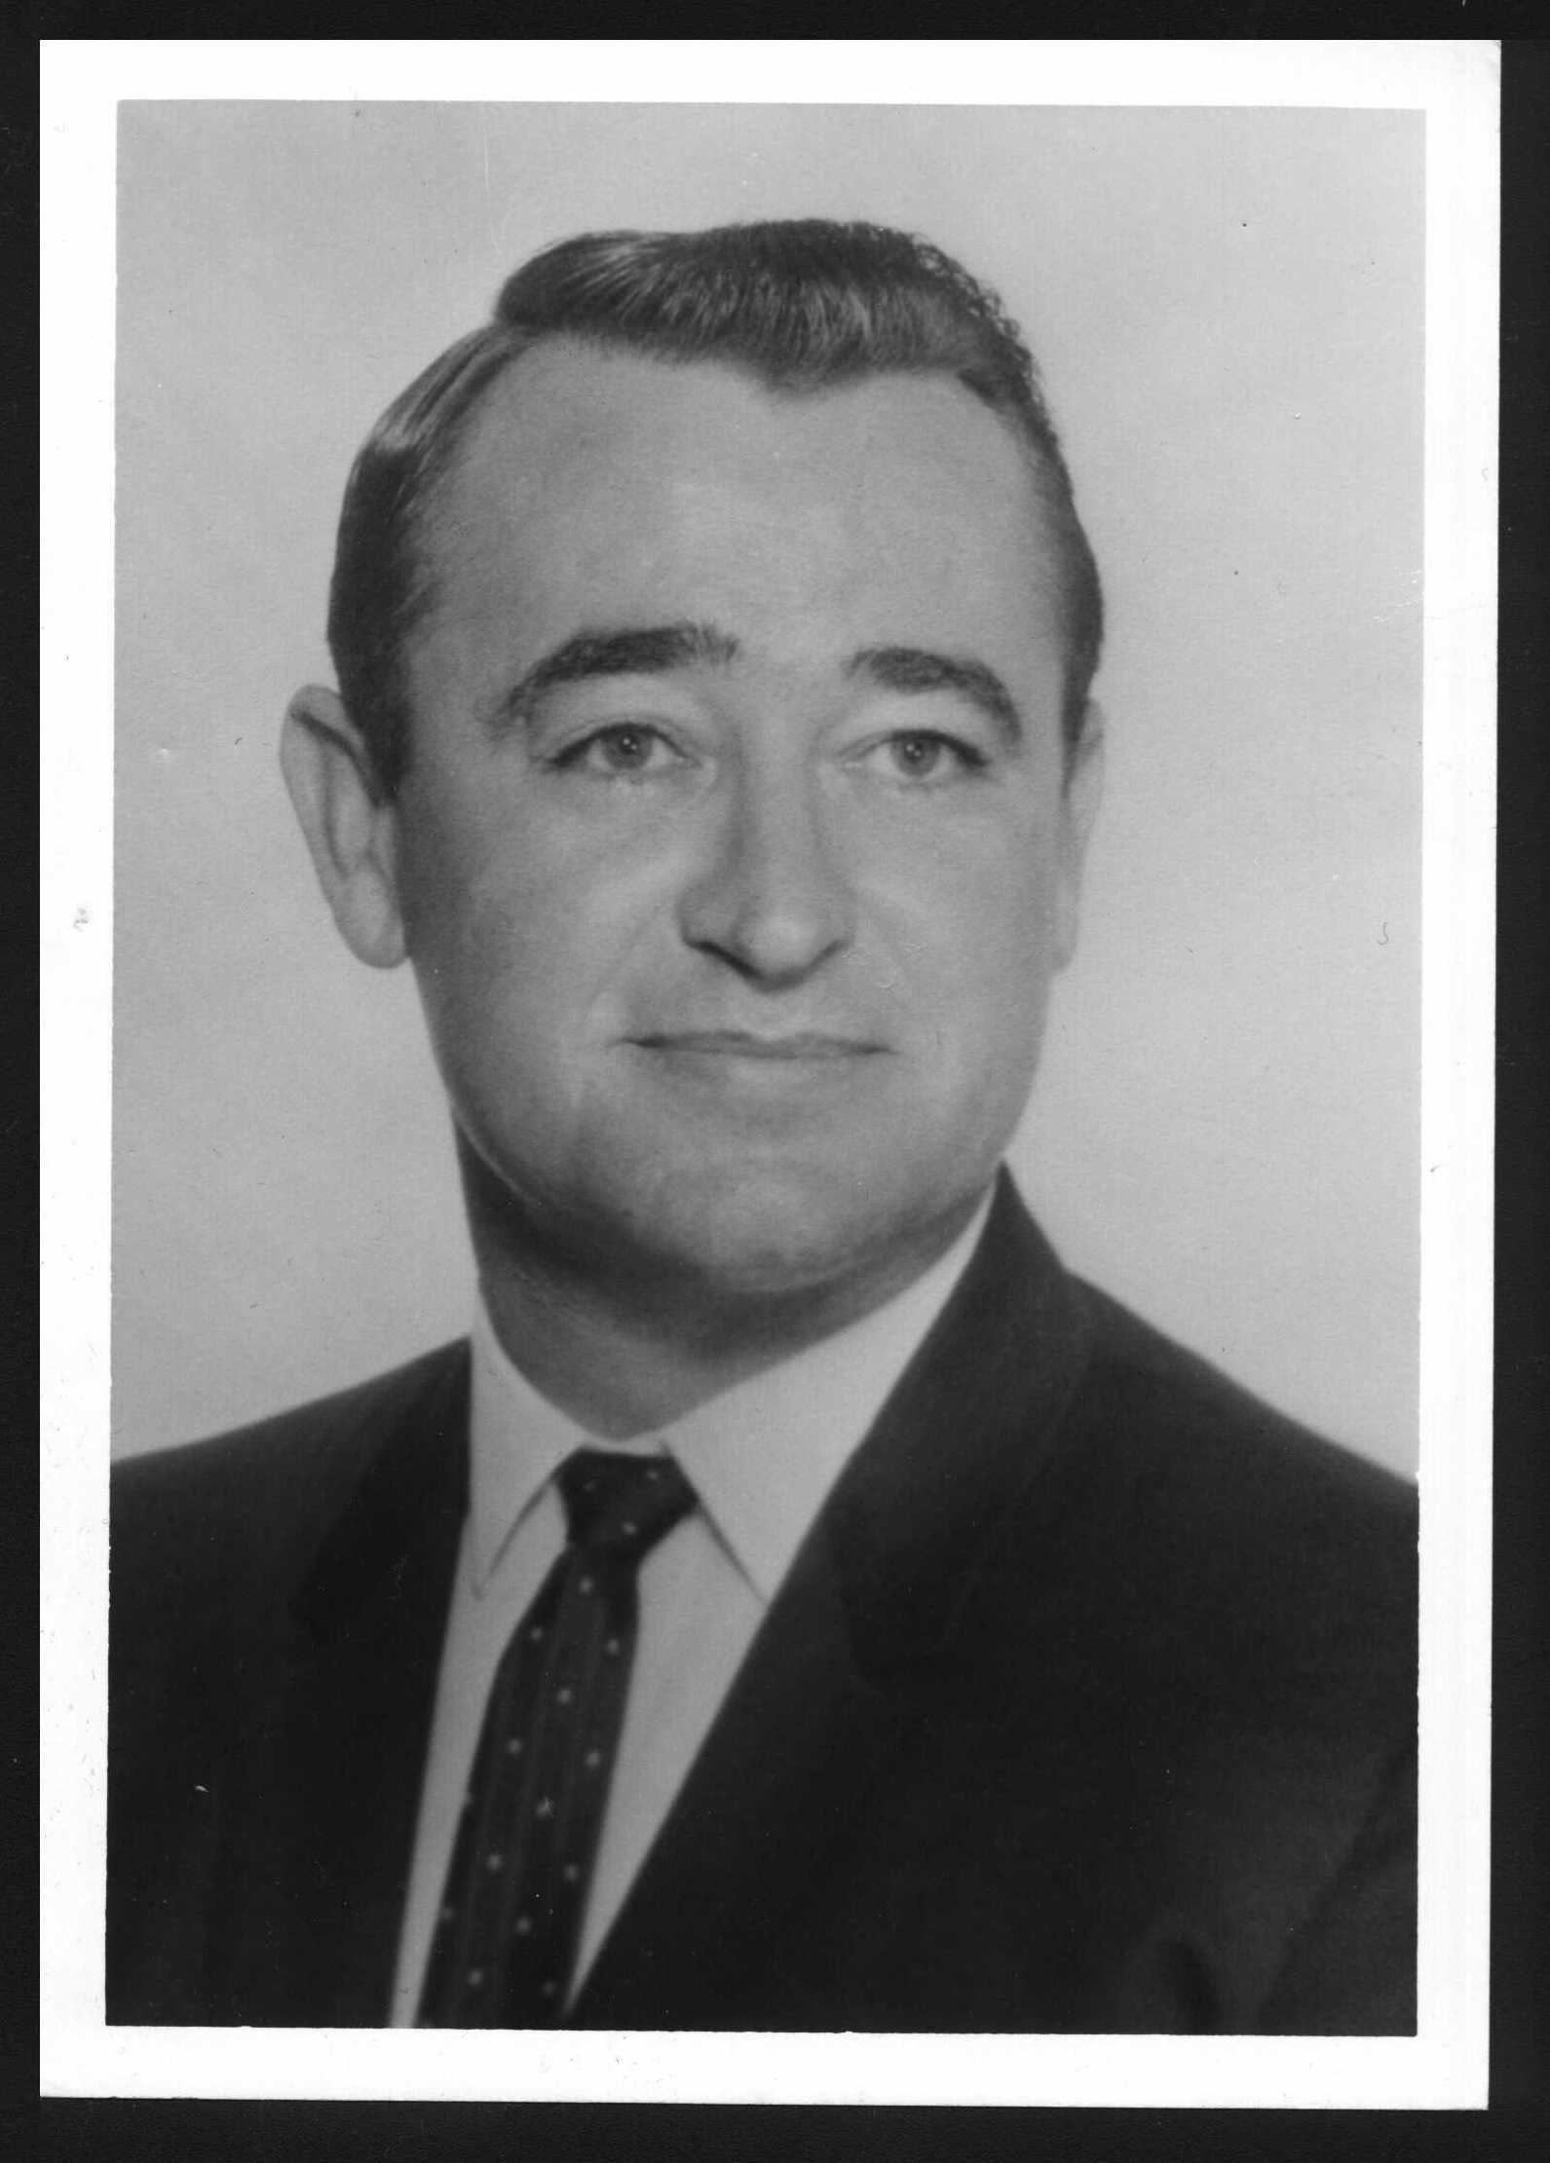
But, without doubt, Jim’s dearest endeavor in his last years was assisting his son, Kevin, in his efforts to follow the Lord’s calling. Together, father and son formed Vine & Fig Tree, Inc., a not-for-profit Christian publishing and philanthropic concern, inspired by Scripture from Micah 4:1-7. Jim kept all financial and legal matters in order, kept computers running, contributed hundreds of hours and thousands of dollars to aid Kevin’s hands-on work with the homeless and recovering drug addicts. Jim and Kevin envisioned and even drew up plans for a Christian Study Center in the Ozarks; a vision that Jim would not live to see realized.
The cancer returned. It was discovered two weeks before Jim’s 65th birthday. And no little lump this time; a monstrous mass had invaded the space in the cavity between lungs and spine.
His reaction to that terrible diagnosis was true to character; with his usual reserved strength and methodical mind, Jim turned to the Lord...and then to his computer. He researched everything he could learn about his type of cancer, every possible treatment option, non-option and alternative available everywhere in the world. Then, naturally, he engineered a treatment plan blueprint. First on his agenda...prayer. Next, he arranged a schedule for chemotherapy infusions, insisting that his doctors only “poison and sicken” him early in the week so as to not interfere with his Saturday golf games. Simultaneously, he readied Plan B, applying for admission in a Phase II Clinical Trial of experimental antineoplaston treatment at the Burzynski Cancer Research Institute in Houston, Texas.
The first two rounds of chemo yielded near miraculous results. The cancer mass was reduced by 90%. Jim gave glory and praise to God, saying, “I just turned this over to Him and the Lord delivered.” And his family hummed the ‘Hallelujah Chorus’ for days without ceasing, believing the battle would be easily won.

Page 5
After moving his bride to Southern California, Marybeth began teaching elementary school while Jim worked full-time to put himself through college. The demands of juggling education, employment, marriage and family caused Jim to drop out of Calculus three times – once because his first child was due to be born on the night of his final exam. He graduated from USC with a degree in Business Engineering, “in only thirteen easy years,” he’d joke.
Lo and behold, Mr. and Mrs. Craig were “fruitful and multiplied;” blessed with a son, James Kevin, followed by a daughter, Amy Elizabeth. Together, they determined to raise their children in a loving, music-filled, Christ-centered home. Before either child could read, they were read to. Nightly, the family snuggled up for bedtime readings from A Child’s Story Bible. This instilled in Kevin and Amy a love for books and for the Lord. Through their church and by their example as well as instruction (along with much prayer and the Grace of God) Jim and Marybeth lived to see their children grow to be a loving brother and sister to each other and in the Lord. The kids even followed their parents’ musical footsteps, taking up trumpet and piano.
Jim Craig sincerely believed, and so stated, that having raised two Christian children was his life’s greatest work and most important accomplishment.
That said, the following must have been some of Jim Craig’s “minor” accomplishments:
James Lee Craig was one of only a few S of O alumni to have been honored with the School of the Ozarks ‘Meritorious Achievement Award’ for his outstanding community service efforts and continual support on behalf of the school that had, literally, changed his life.
He furthered his education, earning a postgraduate Master’s degree in Business Management from Pepperdine University.
He learned to fly a plane, receiving a Private Pilot’s License and becoming a member of the Aircraft Owners & Pilot’s Association.

Page 6
And Jim Craig was a computer electronics engineering “Techno-geek” long before the term was even invented. Among the companies he worked for and with were Northrop Aeronautical Institute, Beckman Instruments and Bell & Howell—the latter becoming Consolidated Electrodynamics Corporation. Such a mouthful of company name caused Jim’s little girl, Amy, to take great pride in proving her ability to spell it. That delighted her Daddy. However, few others could easily even pronounce it so, it was likely a good thing when CEC was acquired by Kodak. A household word. Jim’s work at Kodak’s Datatape Division involved the development, design and installation of scientific instrumentation and recording equipment used in private sector research, military application and NASA. His top security clearances afforded him membership in The Association of Old Crows, an organization of various experts working on very high-tech and pretty “Stealthy” stuff. Just for fun, Jim would tinker in his garage, once building an oscilloscope from scavenged spare parts. (All this long before Bill Gates was in diapers or Al Gore “invented the Internet.”) He ultimately rose to the position of Regional Manager for all Kodak’s US territory west of the Mississippi.
In 1970, Jim Craig made a casual remark to his doctor during a routine physical. He mentioned a lump in his upper leg. Not that it bothered him much; he’d had it for two years. With equal nonchalance, his doctor offered to take it out and Jim consented. On sight, before biopsy, Jim’s doctor knew and told him, “It’s malignant.” Tests confirmed a form of cancer called Squamous Cell Carcinoma.
Major surgery removed lymph glands from his leg. More surgery followed along with chemotherapy. It didn’t faze him when his hair fell out but, oh, how he hated when it grew back in curly! That was his only complaint.
To fight the swelling in his leg, due to the lack of lymph glands, Jim started jogging. Up to five miles a day, everyday. That was followed by diving into the backyard pool, swimming laps.
Jim fought and won that round in the cancer battle. Yet, his doctor told him that Squamous Cell Carcinoma is a kind of cancer that has a nasty tendency to return. And he spoke these prophetic words: “Better get your affairs in order. You’ll be lucky if you don’t get it again between now and your sixty-fifth birthday.”

Page 7
He proved to be more than lucky; he was blessed. God gave Jim twenty-eight more cancer-free years.
Jim returned to his work with undiminished energy, earning high praise or promotions or awards and accruing merit bonuses consistently each and every year of his employment. His own diligence, careful planning and wise investments enabled him to retire at age 55.
That is, if anybody could call this “retirement...”
Upon moving to Desert Hot Springs with Marybeth, Jim took a special interest in the local Palm Springs Christian Schools, volunteering his time and lending his business expertise as their Comptroller. In addition, he repaired and rebuilt salvaged computers for donation to the Christian School students.
He was a member of the American Legion and became active in politics, ultimately nominated and serving as a delegate in the California Republican Assembly.
Then there was the beef cattle business. Jim was far more than a mere “in-law” having married into his wife, Marybeth’s, family of five siblings. Jim became an honorary “Rea,” adopting her father, mother, sisters and brothers as his own. So, Jim sat on the Board of Directors and managed the bookkeeping for Elbow Ranch Corporation, a Rea family enterprise.
And, yes, Jim did manage to indulge in at least one appropriately “retired” activity. Swinging (and admittedly swearing) his way around the Mission Lakes Country Club golf course.

