VINE  FIG TREE
4 43041 Buttonwood Dr. p Palm Desert, CA 92260 5

“And they shall beat their swords into plowshares
And every one shall sit under his Vine & Fig Tree . . . .”
Micah 4:1-5

Friday, July 31, 2026

Mrs. Marybeth R. Craig
P.O. Box 199
Powersite, CA 65731

Re: Contribution

Dear Mrs. Craig,

This letter is to acknowledge your very generous non-cash contributions in the amount of $30,575.53 during the year 2007.

Your generosity will enable us to continue our services in the year to come.

Our EIN is 43-1453835.

Very truly yours, | Fax: (760) 568-9855
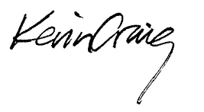 | Phone: (760) 464-6907
 | E-mail: VFTinc@VFTonline.org
 | Web Page: http://VFTonline.org
Kevin Craig

